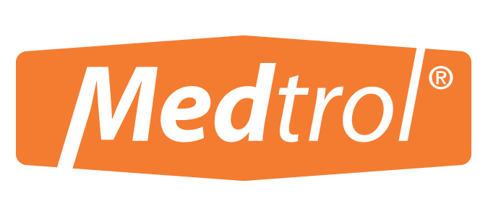

7157 N. Austin Avenue
Niles, IL. 60714
Ph: 800-647-7180 Fx: 800-255-3027
sales@medtrol.com www.medtrol.com

MATERIAL SAFETY DATA SHEET
45823

School Health Sanitary Surface Wipes

SCHOOL HEALTH SANITARY SURFACE WIPES ARE SATURATED WITH
QUATERNARY AMMONIUM CHLORIDE @ 200PPM.
Prepared: April 2009
SECTION I MANUFACTURER INFORMATION

CHEMICAL BLENDER: EMCO CHEMICAL DISTRIBUTORS, INC. PHONE: 847-689-2200
2100 COMMONWEALTH AVENUE EMERGENCY: 800-535-5053
NORTH CHICAGO, IL. 60064

PRODUCT MANUFACTURER: MEDTROL, INC. PHONE: 800-647-7180
7157 N. AUSTIN AVENUE
NILES, IL. 60514

PRODUCT CLASS: BLEND
MFG. CODE ID: 45823
TRADE NAME: SCHOOL HEALTH SANITARY SURFACE WIPES

SECTION II HAZARDOUS COMPONENTS

NO. COMPONENT % BY WT.

1 ISOPROPYL ALCOHOL (IPA) 10.00
2 DIETHYLENE GLYCOL BUTYL ETHER* 190 8.92

>> NONE OF THE COMPONENTS OF THIS PRODUCT ARE RECOGNIZED AS CARCINOGENIC.

SECTION III PHYSICAL DATA

BOILING POINT: 212° F
EVAPORATION RATE: < 1 (ETHER = 1)
VAPOR DENSITY: > 1 (AIR = 1)
% SOLID: 1.68 (THEORETICAL)
WEIGHT PER GALLON: 8.38 (THEORETICAL)
(BOILING POINT REPRESENTS BOILING POINT OF LOWEST BOILING RAW MATERIAL.)

MATERIAL SAFETY DATA SHEET
45823
SECTION IV HEALTH INFORMATION

EYE CONTACT: IN CASE OF EYE CONTACT, FLUSH WITH WATER FOR 15 MINUTES AND CALL A PHYSICIAN.

SKIN CONTACT: SKIN HYPERSENSITIVITY MAY OCCUR IN A SMALL PERCENTAGE OF THE POPULATION. RINSE SKIN WITH WATER FOR 15 MINUTES. IF IRRITATION PERSISTS, CONSULT A PHYSICIAN.

INHALATION: BASED ON THE CONCENTRATION OF ACTIVE INGREDIENT, NO PRESCRIBED REGULATORY PRECAUTION IS INDICATED. IN ISOLATED INCIDENCES, IF RESPIRATORY IRRITATION OCCURS, REMOVE INDIVIDUAL TO FRESH AIR AND CALL A PHYSICIAN.

INGESTION: IF SWALLOWED OR INGESTED, DRINK 1 -2 GLASSES OF WATER. DO NOT INDUCE VOMITING. CALL A PHYSICIAN.

SECTION V FIRE AND EXPLOSION HAZARDS

FLASH POINT: > 200 DEGREES F. TCC

SECTION VI REACTIVITY

STABILITY: STABLE

HAZARDOUS POLYMERIZATION: WILL NOT OCCUR

SECTION VII EMPLOYEE PROTECTION

RESPIRATORY PROTECTION: IN THE CLEANING OF FOOD SERVICE ENVIRONMENTS, NO RESPIRATORY PROTECTION IS PRESCRIBED AT 200 PPM.

PROTECTIVE CLOTHING: GLOVES MAY BE USED IN CASES OF PROVEN SKIN HYPERSENSITIVITY.

ADDITIONAL PROTECTIVE MEASURES: EYE WASH FOUNTAINS AND SAFETY SHOWERS SHOULD BE AVAILABLE FOR USE IN AN EMERGENCY.

SECTION VIII ENVIRONMENTAL PROTECTION

WASTE DISPOSAL:
OBSERVE ALL FEDERAL, STATE, AND LOCAL REGULATIONS REGARDING PROPER DISPOSAL.

THE INFORMATION CONTAINED HEREIN IS BASED ON THE DATA AVAILABLE TO US AND IS BELIEVED TO BE CORRECT. HOWEVER, WE MAKE NO WARRANTY, EXPRESSED OR IMPLIED REGARDING THE ACCURACY OF THIS DATA OR THE RESULTS TO BE OBTAINED FROM THE USE THEREOF. WE ASSUME NO RESPONSIBILITY FOR INJURY FROM THE USE OF THE PRODUCT DESCRIBED HEREIN.

